**Gracious Germents**

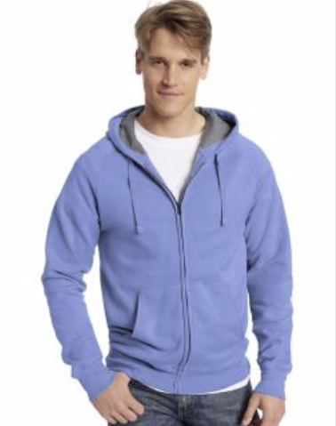

**DESCRIPTION:**

Hanes ComfortBlend® EcoSmart® Pullover Hoodie Sweatshirt

Hanes

ComfortBlend

P170

Units per Pack:1

**ADDITIONAL INFORMATION**

Weight: 0.5 kg

Dimensions: 10 × 8 × 3 cm

Size: S, M, L, XL,

Price: $25.00